Title:-
Protein Sequence Analysis using BLAST

Objective
To analyze a DNA/protein sequence using BLAST tool and identify homologous sequences based on similarity, identity, and alignment score.

Database and Tools Used
- NCBI BLAST (https://blast.ncbi.nlm.nih.gov)
- Protein sequence retrieved from NCBI
- BLASTp used
Procedure
- A protein sequence was downloaded from NCBI
- The sequence was pasted into BLAST tool.
- BLASTp was selected for protein comparison.
- Database “nr” was used for searching homologous sequences.
- BLAST results were analyzed based on identity, similarity, and E-value.
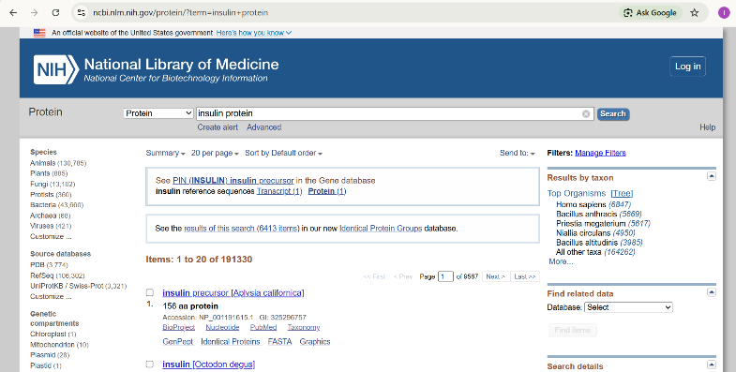
Figure 1 Search results for insulin protein retrieved from the NCBI database showing multiple protein entries across different organisms.

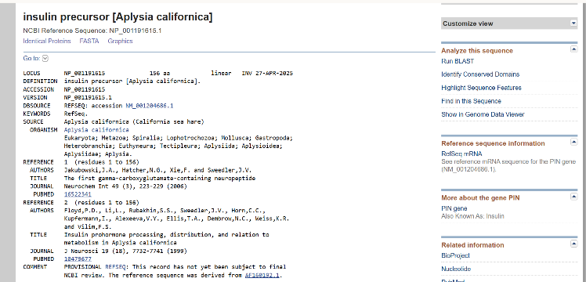
Figure 2 Detailed information of the insulin precursor protein from Aplysia californica obtained from the NCBI, including accession number (NP_001191615.1), organism, and protein description.

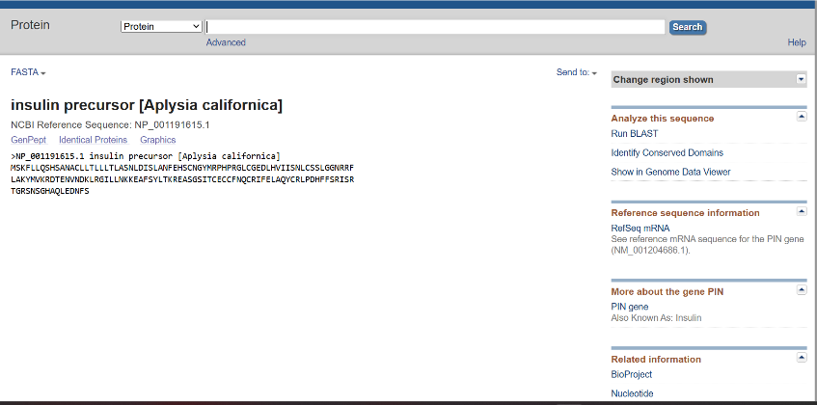
Figure 3 FASTA format of the insulin precursor protein sequence from Aplysia californica used as input for sequence similarity analysis using BLAST.
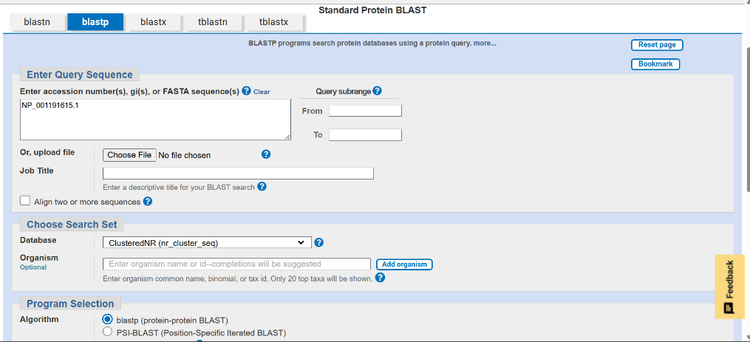
Figure 4 BLASTP input interface showing the query protein sequence (accession NP_001191615.1) and selected parameters.

Results:
- Top hit: Homo sapiens insulin precursor
- Sequence length: 156 amino acids
- Identity: 100%
- Positives (similarity): 100%
- Query coverage: 100%
- Bit score: 320 bits
- E-value: 0.0

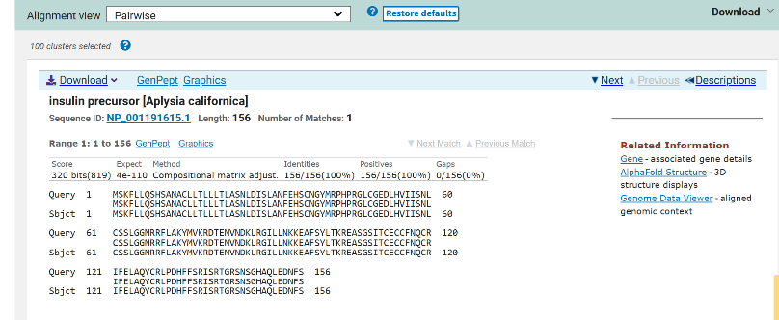
Figure 5 Pairwise sequence alignment between the query insulin precursor protein and the top homologous sequence, illustrating conserved regions and sequence similarity using BLAST.

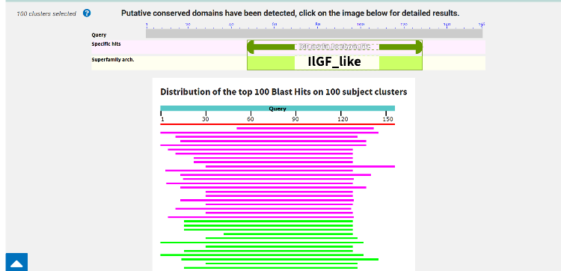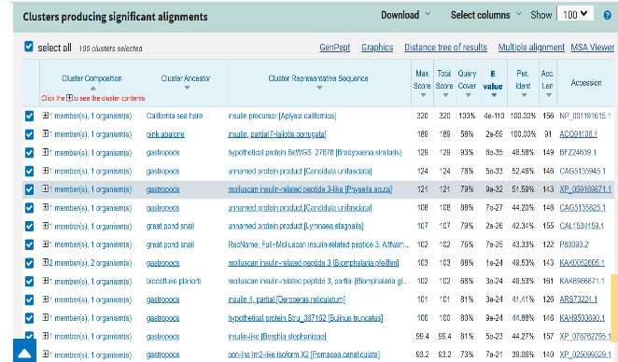
Figure 6 Graphical overview of BLAST alignments Figure 7 Clustering of sequences producing significant
Highlighting regions of sequence similarity and alignments with the query insulin protein, showing groups
conservation. of homologous sequences based on similarity
Interpretation
- High identity indicates strong similarity between sequences.
- Low E-value (near 0) shows statistically significant alignment.
- Conserved regions suggest evolutionary importance of protein.
- Similar sequences in different species indicate homologous relationships.

Conclusion:
The chosen protein sequence, human insulin precursor (Homo sapiens), was used for BLASTp search. From the results, it is evident that the protein shows high levels of identity and similarity to other organisms' insulin proteins. Very low E-value signifies a statistically significant match. The high levels of query coverage and alignment scores also indicate high conservation of the protein sequence, implying that the insulin protein has a great biological significance and evolutionary conservation.

